SUDAMA PASAET 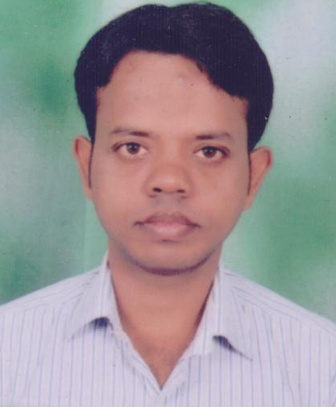
Address: AT/PO - Bhukta, Distt- Bargarh, Orissa Pin Code-768045.
Email:pasayat82@gmail.com
Contact No. – 8427979591, 9988755024
Current Location : Raipur ( Chhattisgarh )

OBJECTIVE

To Excel in the IT Industry where i can Utilize the right mix of my skill sets.

WORKEXPERIENCE

Job at TCI EXPRESS LTD (Transport Corporation of India Limited)
Duration - (Feb-2007 to Oct-19)
Job Detail - 2007 to 2013 as a IT Senior Supervisor.
Job Position –Marketing With KAM operation Officer. (2014 to 2019)
Location – Ambala
Job Profile – . IT (2007 to 2013)
. All Branches System, Printer, UPS, Netware with CCTV Maintain.
. Daily Basis Monitoring Barcode Scanner work properly or not.
. Data entry. Prosperity Report Update.

Operation (2013 to 2016)
. Delivery Consignment unloading, MR & DC challan prepare, DC Close.
Pod upload & Dispatch.
Railway c/ment Collect to Railway Station (2007-2008).
. Ecommerce consignment Delivery Follow.

KAM (2017 to 2018)
. Cargo consignment Delivery Follow on Daily Basis (Branch Office to Customer
end)
. Customer Follow
. Consignment Actual Status Update in Customer side.

Marketing & Sales (Apr-2018- oct-19)
. Mahindra & Mahindra Customer All C/ment Follow Booking Station
to Deliver Station .
. New Customer Create.
. Meeting to Customer Increase Booking & Delivery.
. Research & develop strategies to indentify the business opportunities in the
Market.

Job at – Barbrik Project Limited
Duration- Jan-2020 to Sep-2020
Job Profile - Billing Supervisor ( Mechanical & Store Dept )
Location - Rourkela ( Odisha )

Current Job at – Spoton Logistics Ltd.
Duration- Nov-2020 to Till Date
Job Profile – Asst. Operation
Location - Sambalpur (Odisha)

Operation work
. Vehicle Loading & Unloading
. MR & DC challan prepare, DC Close.
. Pod upload & Dispatch.
. Booking C/ment Entry & Dispatch.

ACADEMIC PROFILE
Allahabad Jetking
Certified Hardware and Networking Professional in the year 2010
ANNEX Computer Center Bhukta, Bargarh (Certiffied center - IIET )
PG Diploma in Computer Application (2011-2012)
Mahatma Gandhi Degree College Bhukta, Bargarh
Bachelor of Art’s (2001-2004)
Council of Higher Secondary Education Orissa
12th in Art’s (2001)
Board of Secondary Education Orissa
10th (1998)
SOFTWARE SKILLS

- PC & Hardware Maintenance,
- Windows 98,XP,Win-7, Linux 14.4, 18.1,19.0 vr, operating, MS office,
- ERP,
- Typing Speed 45mm.

KEY SKILLS
- Ability to learn and execute fast,
- Hard work,
- Self motivated,
- Dedicated, Determined,
- Problem solving ability.

PERSONAL DETAILS

Address : AT/PO - Bhukta, Distt- Bargarh, Orissa. Pin Code -768045.
Date of Birth : 01-Jun-1983
Nationality : Indian
Hobby : Traveling
Gender : Male
Status : Married
Languages Know: Oriya, English, Hindi, and Chhattisgarhi

DECLARATION

I hereby declare that all the information gives above is correct according to the best of my knowledge and belief.

Date :
Place : (SUDAMA PASAAET)

